Rapport du projet (Anglais)

Projet de Programmation

L3L1
Illustration 1: Image de présentation

Les informations d’identification du document : Les éléments de vérification du document :
Validé par :
Validé le :
Soumis le :
Type de diffusion :
Confidentialité :
Référence du document :

Version du document : 1
Date du document :
21/04/2022
Auteurs :
Youstina Abdel Massih
Thierno Bah
Pathé Mbaye Ndéye
Mehdi Hamiche

Maître d’ouvrage : | Chef de projet :
Date / Signature : | Date / Signature :
Les éléments d’authentification :

Sommaire
1. Introduction 5
2. Reading guide 6
2.1. Subject Mastery 6
2.1.1. Responsable 6
2.1.2. Administrative staff 6
2.1.3. Technical staff 6
2.2. Project management 7
2.2.1. Responsable 7
2.2.2. Administrative staff 7
2.2.3. Technical staff 7
3. Knowledge / Development / World of work 8
4. Languages – Software - Environments 10
5. Different phases of the project 11
5.1. Documentation phase 11
5.2. Development phase 11
5.3. Tests phase 11
5.4. Encountered difficulties 12
6. Main features 13
7. Closing 14
8. Annex 15
9. Glossary 16
10. References 17
11. Index 18

1. Introduction
This third year of the bachelor's degree, an IT project had to be carried out as part of the teaching unit Project. The choice of this project was made by the desire to deepen the discovery of programming languages, but in particular to be able to design by our own means a mobile application which really corresponds to us in terms of criteria and use.
This teaching unit therefore aims to make us discover the challenges as developers by carrying out a complete project in a limited time, while respecting certain constraints and rules.
Thanks to this project, we had the opportunity to put ourselves in the shoes of a developer and to discover in depth the ways of working, learning and putting ourselves into practice (vis-à-vis) the development, at the help from the supervisor and our personal efforts.
The project we have chosen is the L3L which consists in creating a smartphone application allowing the user to obtain a precise and sensitive route of his path (by car, bus, motorbike, etc.).

2. Reading guide

2.1. Subject Mastery
The project manager presents the development team responsible for the proper monitoring of the project report and the needs ordered by the contracting authority.
She represents the development team:
- Youstina Abdel Massih
- Thierno Bah
- Pathé Mbaye Ndéye
- Mehdi Hamiche
This team will ensure the proper follow-up of the project report representing the needs of the supervising teacher.

2.1.1. Responsable
This team will ensure the proper follow-up of the project report representing the needs of the supervising teacher.

2.1.2. Administrative staff
It is advisable for the administrative staff to read the knowledge part, the main functionalities as well as the different phases of the project.

2.1.3. Technical staff
It is advisable for the technical staff to take into account the part on the different phases of the project as well as the languages, software and environments.

2.2. Project management
In our case, the project owner represents the client of the project, that is to say the people whose needs allow the design of the project.
The project management is assisted by the project management team and therefore this role will be provided by the supervising teacher Flavie Tonon.

2.2.1. Responsable
This team will ensure the proper follow-up of the project report representing the needs of the supervising teacher.

2.2.2. Administrative staff
It is advisable for the administrative staff to read the knowledge part, the main functionalities as well as the different phases of the project.

2.2.3. Technical staff
It is advisable for the technical staff to take into account the part on the different phases of the project as well as the languages, software and environments.

3. Knowledge / Development / World of work

- Environment
  - Development environment for developing Android mobile applications : https://developer.android.com/studio?hl=fr&gclid=Cj0KCQjwgYSTBhDKARIsAB8KuktzDN4F0N1KgZu1Tlems1pzjIfU67MhqFr7r6C5SGZH_JMTUi8yok8aAku9EALw_wcB&gclsrc=aw.ds

- Data - Extraction / Recovery
To retrieve the test .apk files, you must go to the forge at this address :
https://forge.ens.math-info.univ-paris5.fr/projects/2021-l3l1/repository

- Storage
Here are the different files that can be compatible with our project :
- .apk

- Use during the Development / Production / Development of the KOURTE application
- Drawing of a sensitive route in real time
- Download an image of the route to the phone
- Enter the information of a route and save the route on the database of the application to then find the route in the history

- Meeting with the world of mobile application developer

- Openness to the real world in the situation of a computer scientist
Future improvements envisaged :
We have considered improving our application in the future so that it is more complete and that it can appeal to future customers. For example, improving the route with a "Stop" button or changing the color of the route for a more playful purpose (for children).

4. Languages – Software - Environments
- Understand the usefulness / importance of all these languages ​​during development on KOURTE's Android Studio

Android Studio – JAVA and XML
Android Studio mainly allowed us to edit the Java files and the XML configuration files of the Android application. Among other things, it offers tools to manage the development of multilingual applications and allows rapid visualization of the layout of screens on screens of various resolutions simultaneously.
It also includes an emulator to run a virtual Android system on a computer.

SQLite
SQL language that allowed us to store the information of a plot on the application database to find this information in the history.

5. Different phases of the project

5.1. Documentation phase
The beginning of the project began with the reflection phase, how the project was going to unfold week by week and having an idea on the design of it.
For this, we first designed the specifications to set ourselves objectives and to have a general idea of ​​the structure of our mobile application and the website (the website could not be finished).
Thereafter, comes the recipe book which is used to list the expected functionalities of the application and which will have to carry out the tests. Documents such as the user manual (general design) is there to guide the user on the use of the mobile application.

5.2. Development phase
Arriving at our development phase, we first wanted to leave as we had planned on the specifications. Suddenly, we really started to move forward and so the main problem we had from that point on was the compatibility of our versions of phones with each other from different brands.
However, we had to refer to different solutions to have optimal compatibility with different brands of smartphones.

5.3. Tests phase
We have tested the application each time a feature is added in order to check whether it is compatible with what is already functional.
This allowed us to see what was wrong and to provide the solution.
The tests carried out are :
- the sensitive route
- route recording
- downloading the route
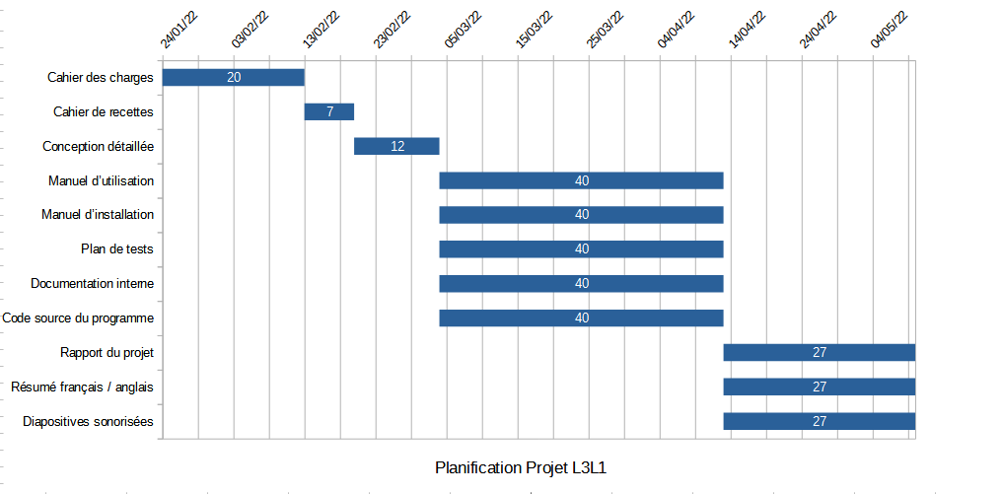Illustration 2: Diagramme de Gantt

5.4. Encountered difficulties
Among the difficulties encountered during our project :
- Compatibility with smartphones of different brands
(Solution: check androidmanifest.xml file)
- Downloading the image of a Route
(Solution: add to androidmanifest.xml: android:requestLegacyExternalStorage="true")

6. Main features
The different strengths of our application:
- Drawing of a sensitive route in real time
  - Using phone sensors
Download an image of the route to the phone
  - Store in gallery (Pictures folder) of phone • Enter the information of a route and save the route on the database of the application to then find the route in the history ◦ Date ◦ Mode of transportation • History menu ◦ Number of points, mode of transport and date ◦ Delete a path ◦ Show full-screen plot
- Download an image of the route to the phone
  - Store in gallery (Pictures folder) of phone
- Enter the information of a route and save the route on the database of the application to then find the route in the history
  - Date
  - Mode of transportation
- History menu
  - Number of points, mode of transport and date
  - Delete a path
  - Show full-screen plot

7. Closing
This project allowed us to realize what an IT project represents and what is important during such a project. We have seen the importance of having a precise direction to move forward effectively.
We have also become aware of the importance of communicating well because this could lead to incompatibilities which could cause delays later. For each member of the group, this is our second “real” IT project and we are happy to have been able to benefit from this experience.
Indeed, this project is a first pseudo-professional experience that allowed us to get a better idea of ​​IT project management in the world of work. This also gives us a basis to be able to continue each on our side to work on this mobile application and to be able to always improve it and develop our skills.
We would like to thank Ms. Flavie Tonon who took charge of supervising our project and who advised us during its entirety.

8. Annex
- Android Studio java documentation
- Specifications
- The recipe book
- The model
- General design
  - Detailed design
  - The user manual
  - The installation manual
  - The test plan
  - Internal documentation
  - The source code of the project

9. Glossary
- REPORT : Document which may contain all the information not included in the other documents requested.
- MOBILE APPLICATION : Application software developed for a mobile electronic device, such as a personal assistant, a mobile phone, a smartphone, a digital music player, a touch pad, etc.
- APPLICATION : Program or set of programs intended to help the user of a computer for the processing of a specific task
- SOURCE CODE : Code written in a programming language and which can be converted to constitute an executable program
- .APK : from the acronym Android PacKage, file extension Equivalent to “.exe” on Windows
- ANDROID : Giant software for mobile phones, tablets and many other devices that can be smart, such as some cars. It is the most widely used mobile operating system in the world. It allows communication between a user and his device

10. References
https://www.ens.math-info.univ-paris5.fr/projets-informatiques/projets/documentation
https://developer.android.com/docs
https://developer.android.com/studio?hl=fr&gclid=Cj0KCQjwgYSTBhDKARIsAB8KuktzDN4F0N1KgZu1Tlems1pzjIfU67MhqFr7r6C5SGZH_JMTUi8yok8aAku9EALw_wcB&gclsrc=aw.ds
https://forge.ens.math-info.univ-paris5.fr/projects/2021-l3l1/repository

11. Index
Index des figures
Illustration 1: Image de présentation 1
Illustration 2: Diagramme de Gantt 12
Index lexical
android 17
Android 15
Android Studio 10, 15
data 8, 10, 13
Data 8
database 8, 10, 13
development 5 sq., 10 sq.
Development 3, 8, 11
Drawing 8, 13
environment 6 sqq.
Environment 3, 8, 10
Extraction 8
forge 8, 17
image 8, 12 sq.
Image 18
improvements 9
java 15
JAVA 10
l3l 8, 17
L3L 1, 5
menu 13
phase 11
project 11
projet 1, 17
Projet 1
recording 12
route 5, 8 sq., 12 sq.
Route 12
save 8, 13
sensitive 5, 8, 12 sq.
SQL 10
XML 10
8
.apk 8
.APK 16

